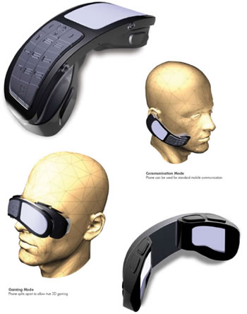
MOBILE PHONES OF THE FUTURE

Mobile phones have developed at an incredible rate over the last few years. They have many features such as allowing you to take photographs, listen to your favorite music, access the Internet and of course, make phone calls.

Every year, something new seems to be added to the latest version of mobile phones. New, innovative designs are being launched all the time.

TASK

Your task is to design a mobile phone which will be available in five years time.

Think about the features which it might offer – remember this is for the future, so those features don’t have to be possible right now.

Think about the design, will the phone be larger, smaller or a different shape to those we have now?

Think about the buttons, will it be a standard telephone keypad or will there also be a keyboard keypad?

- Draw a detailed picture of your new mobile phone.
- Draw arrows and label the features.
- Write a short paragraph discussing the features available on your phone and the design ideas that you came up with.
- Extension:- create icons for all/some of the newly created tasks

